19BCE2311 Gaurav Singh

Assessment 1

Screenshots:

Q1

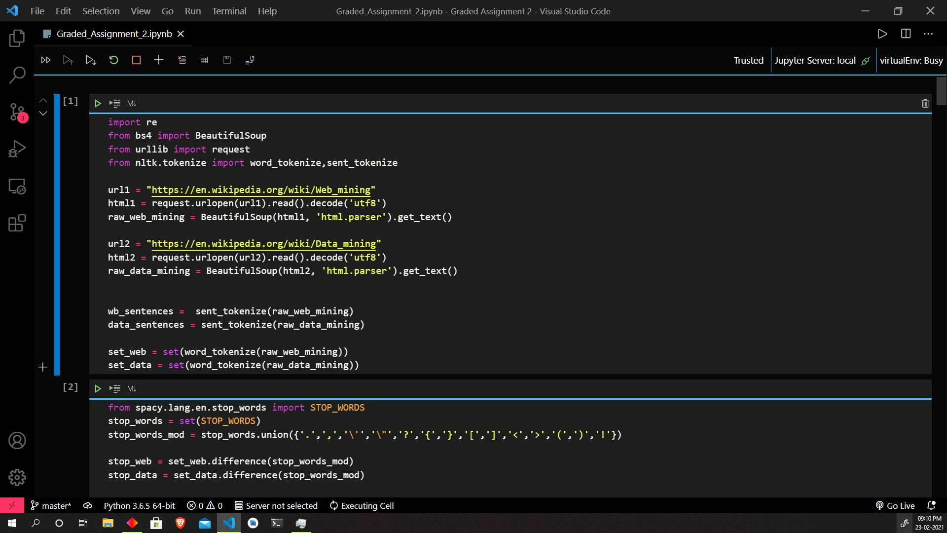

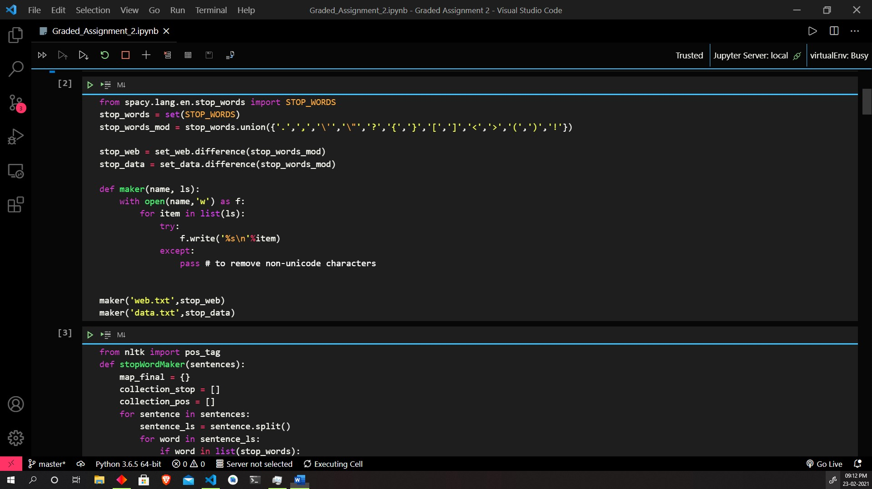

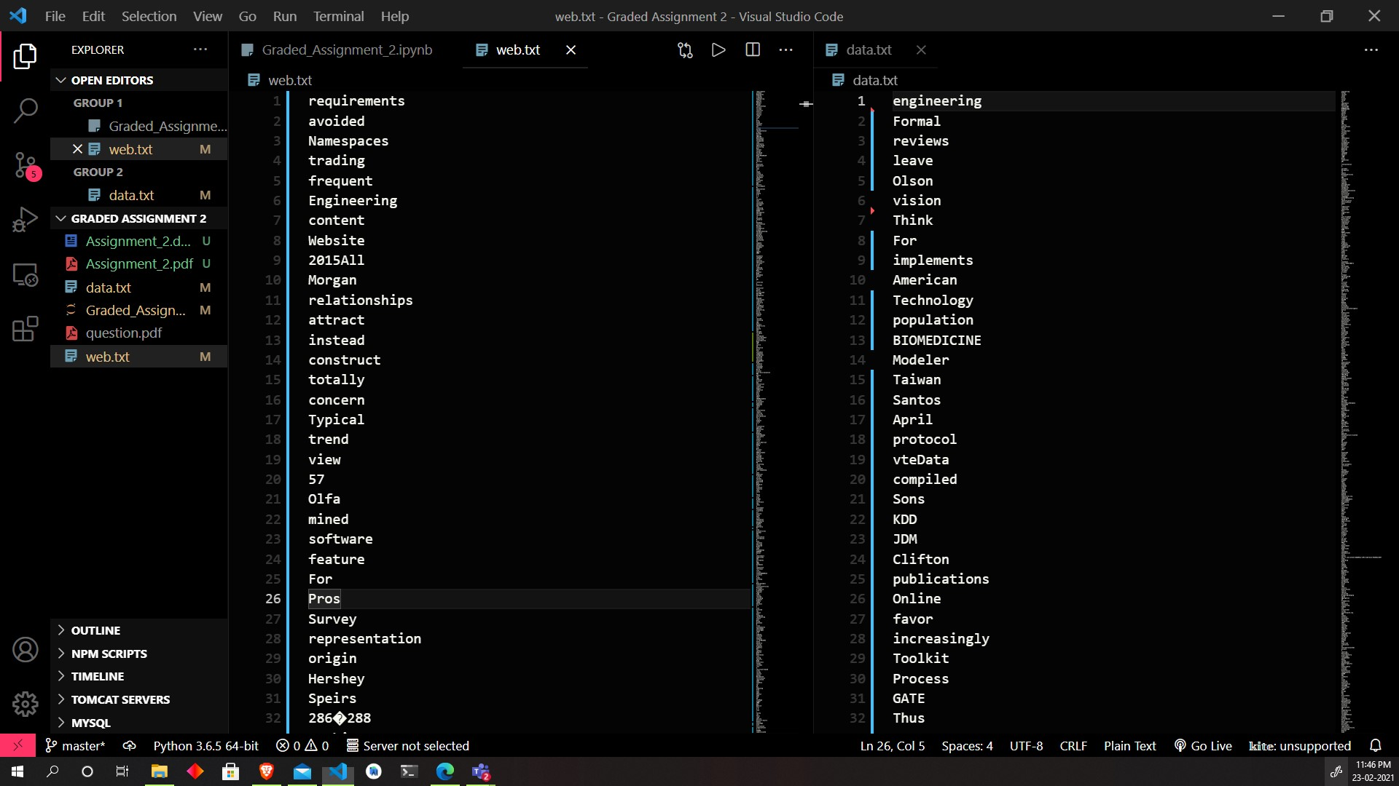

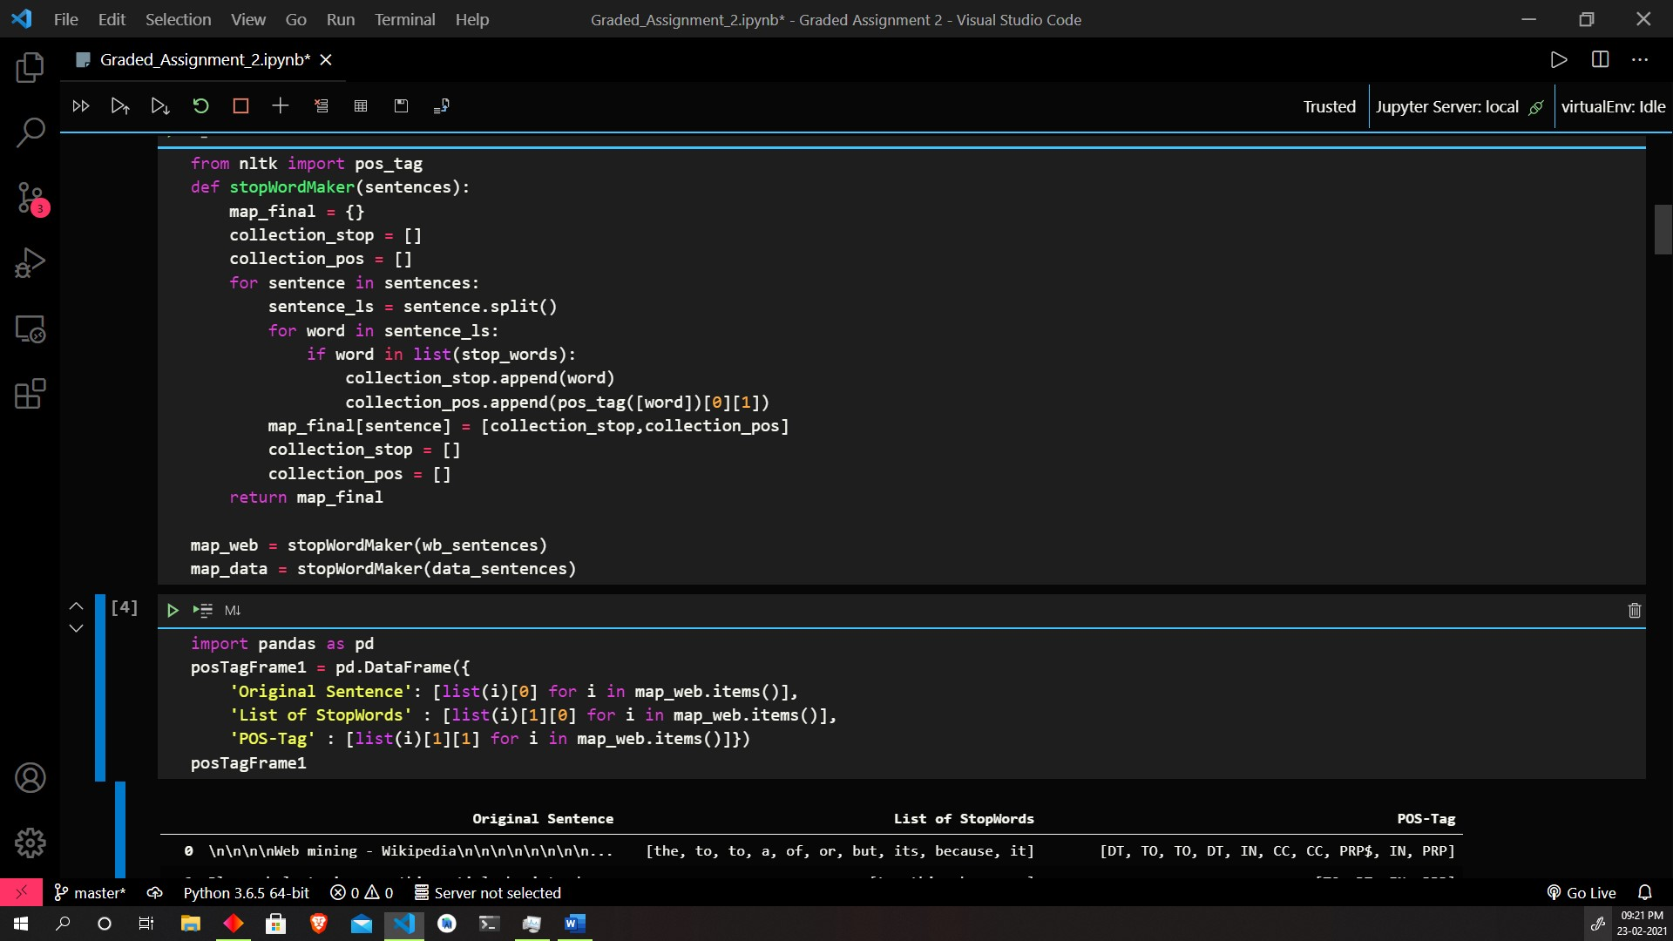

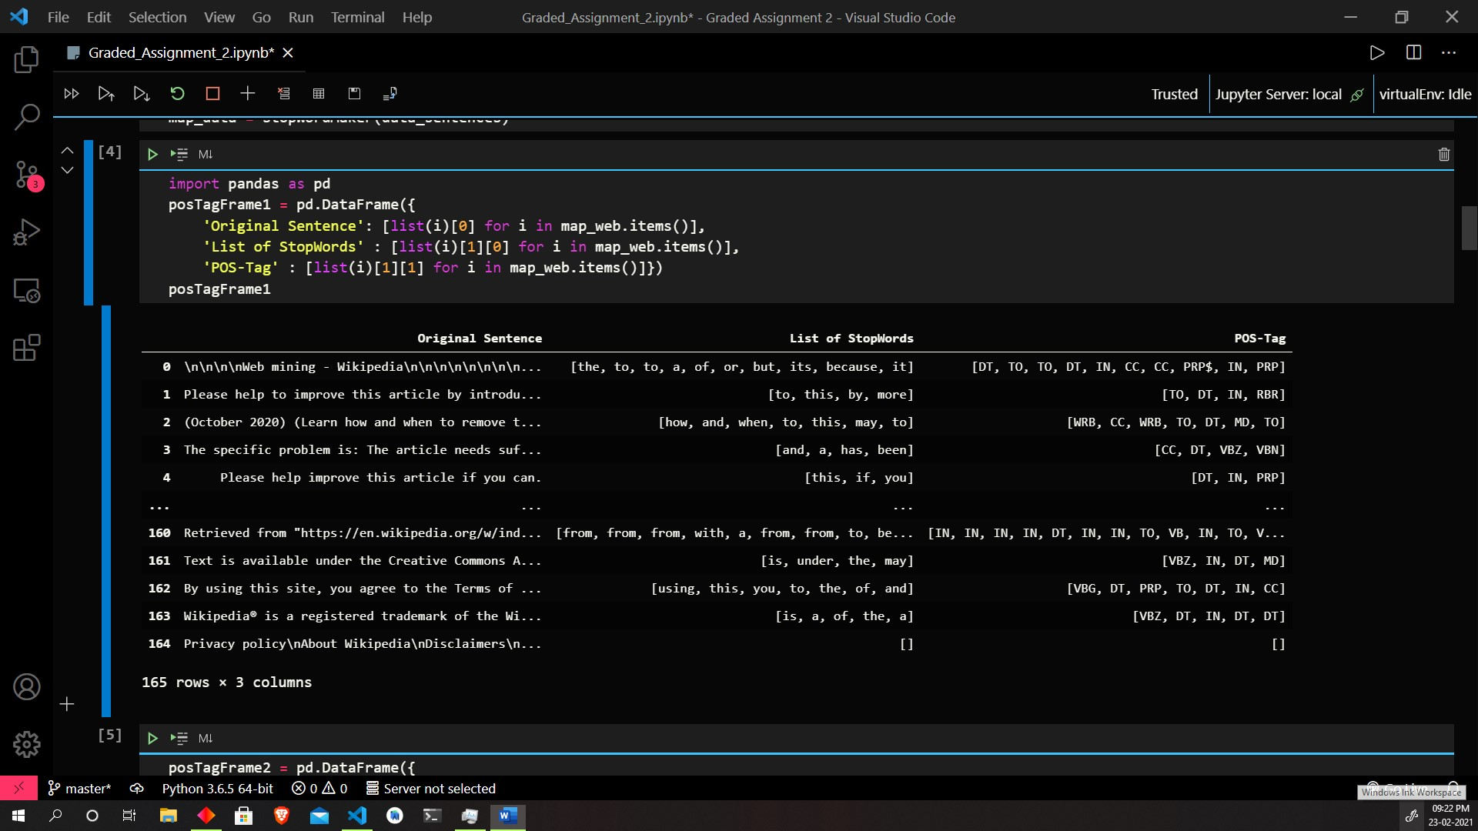

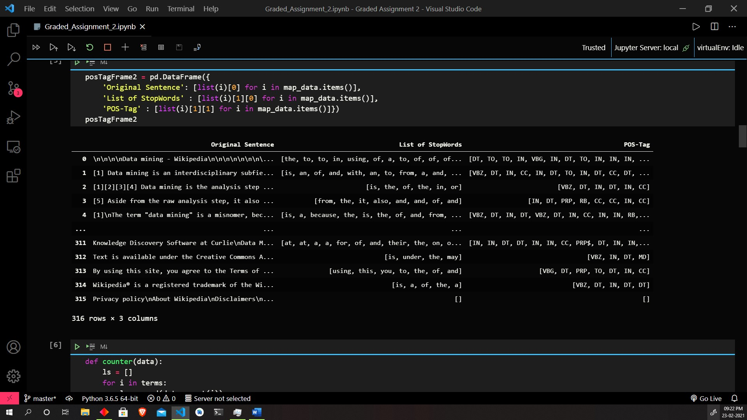

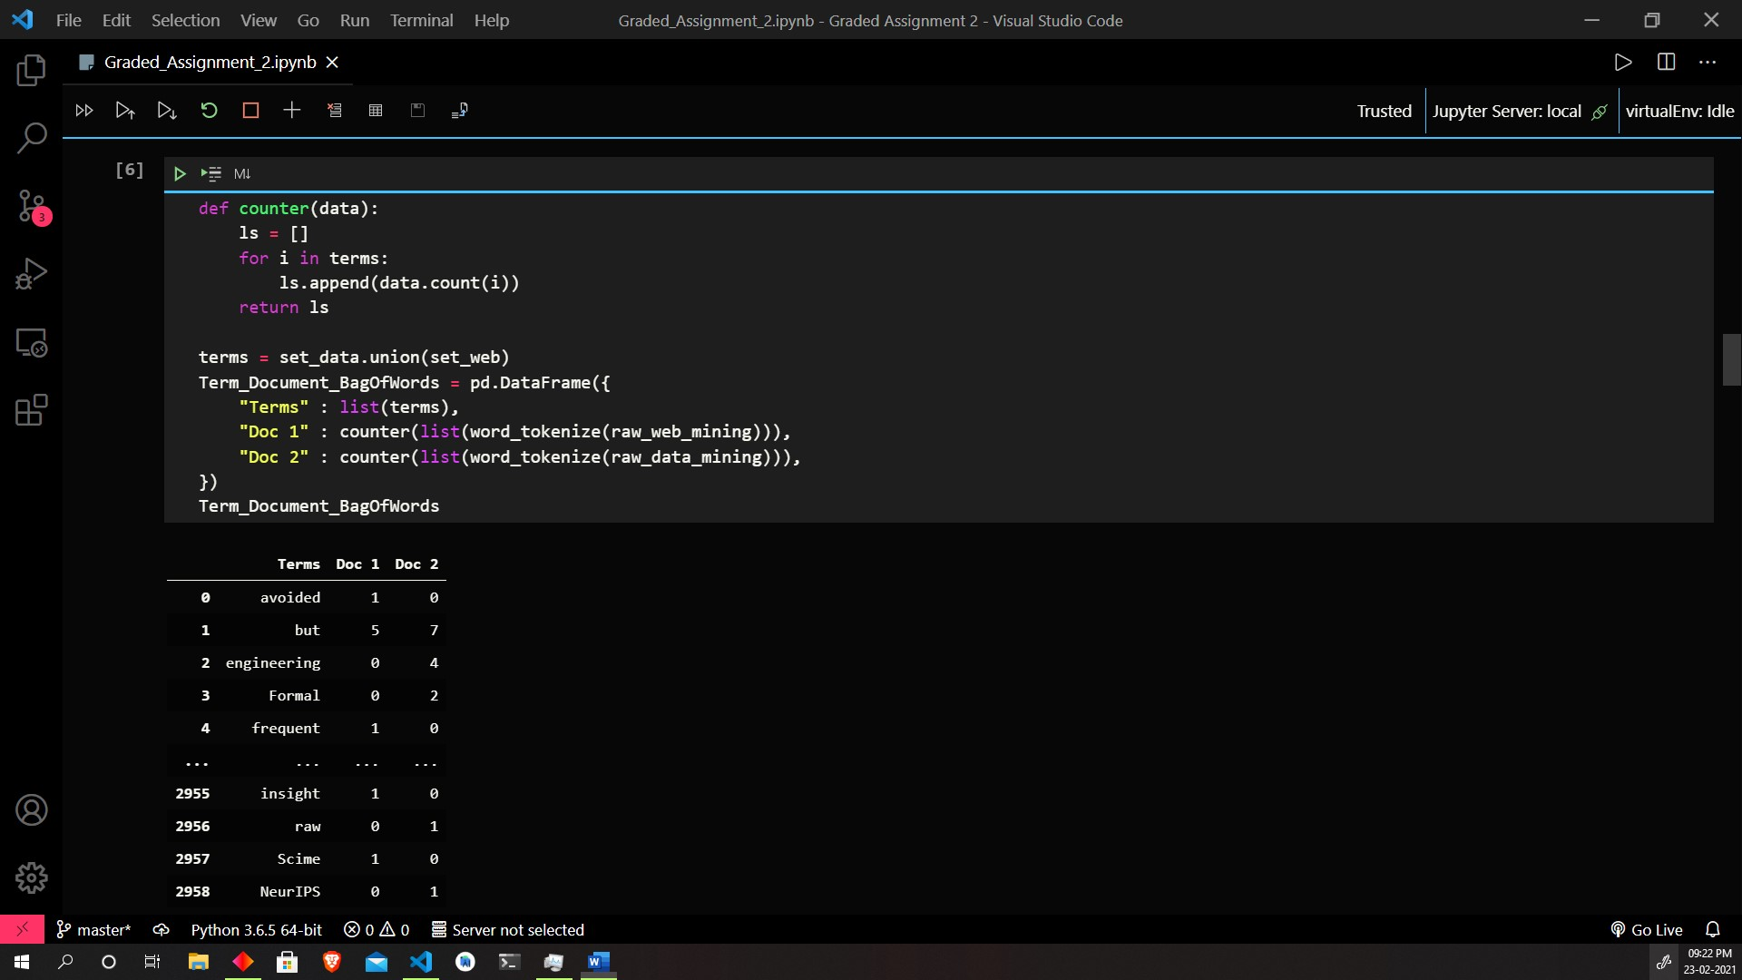

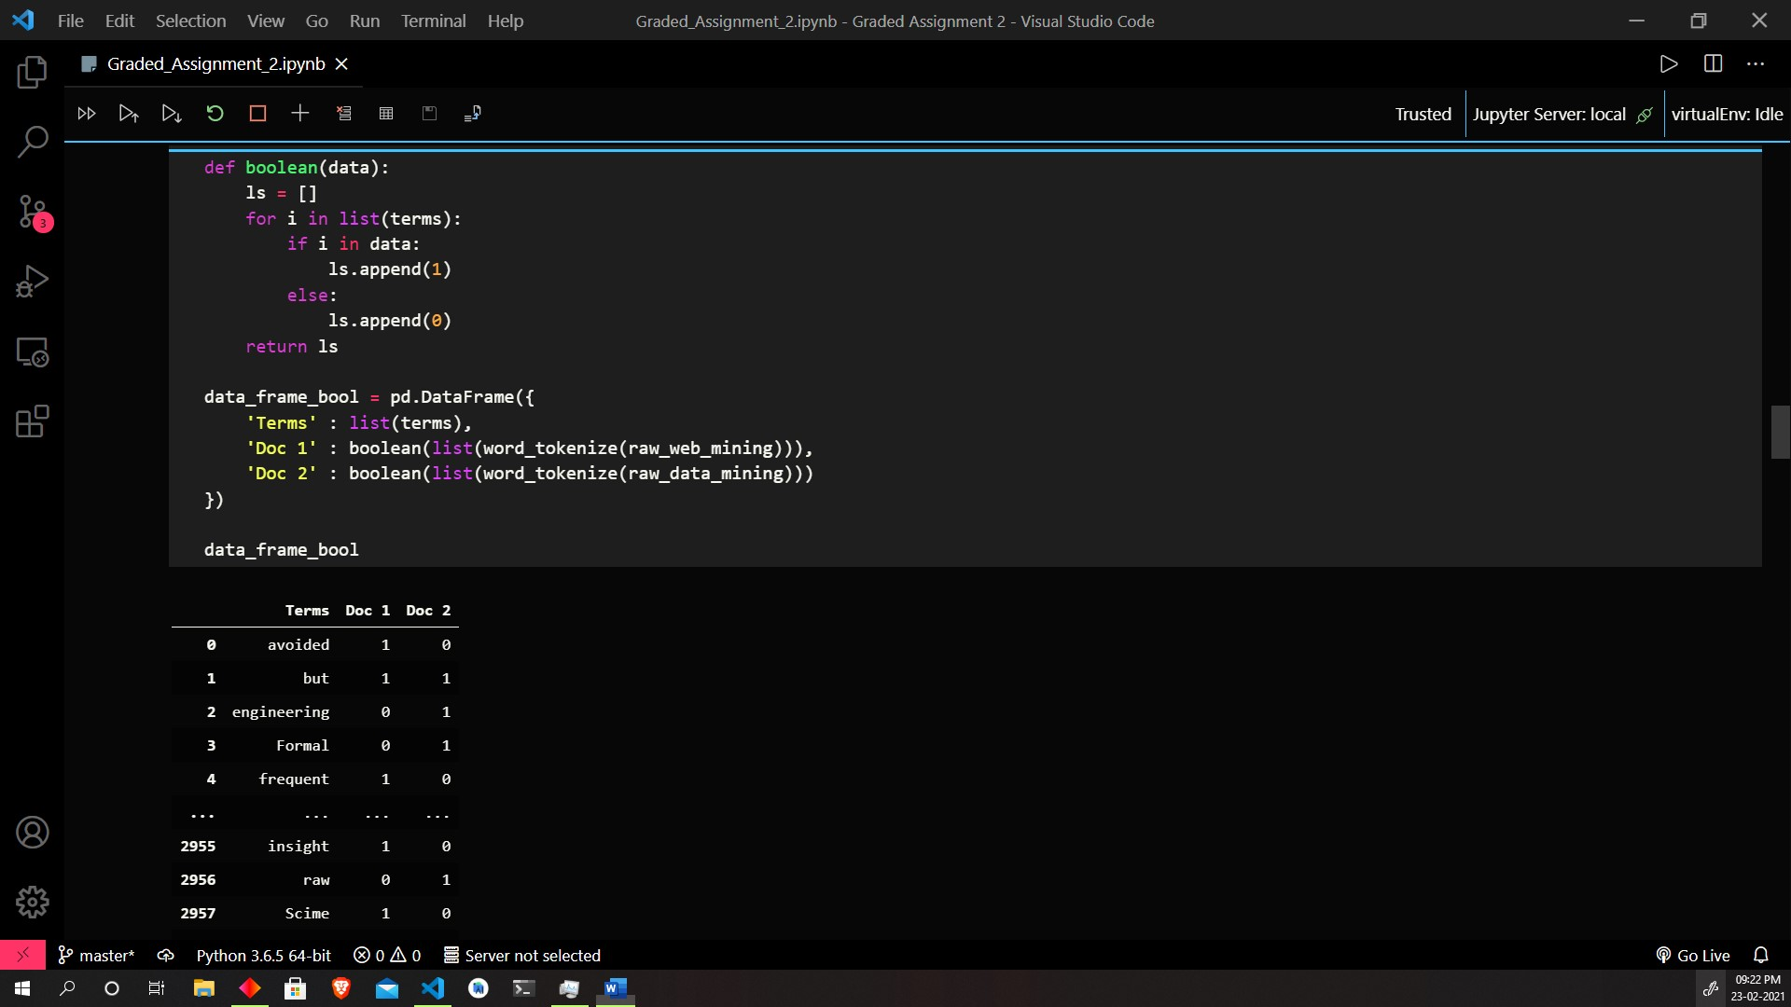

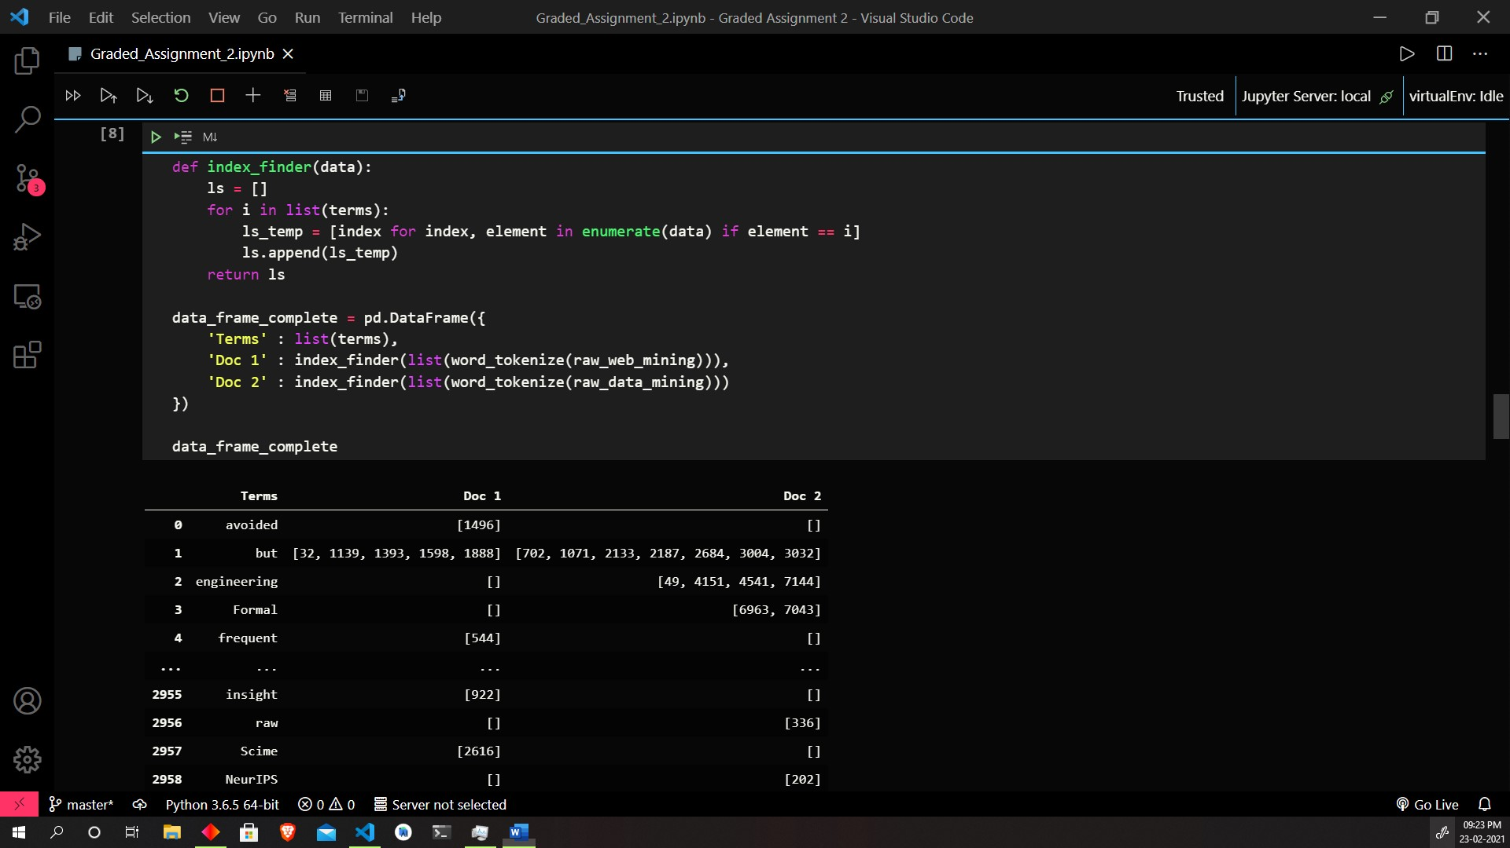

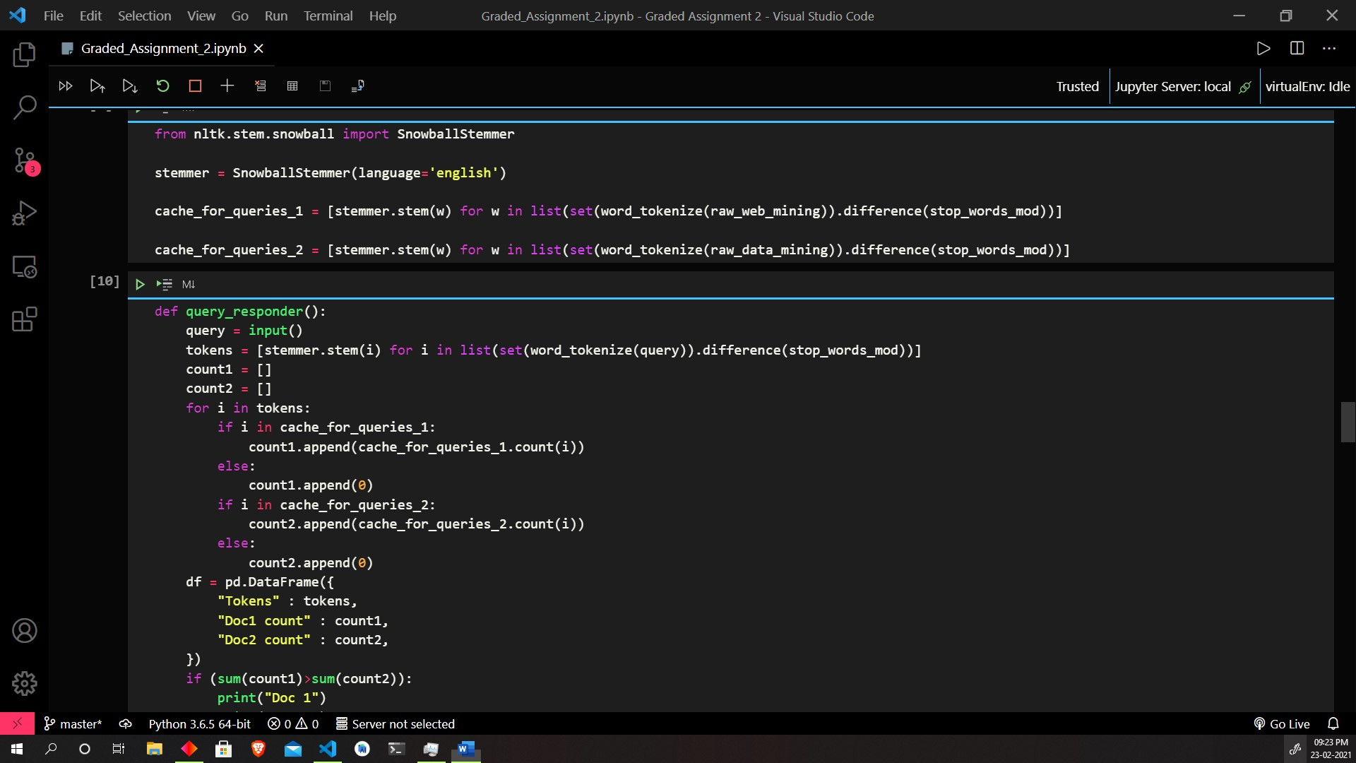

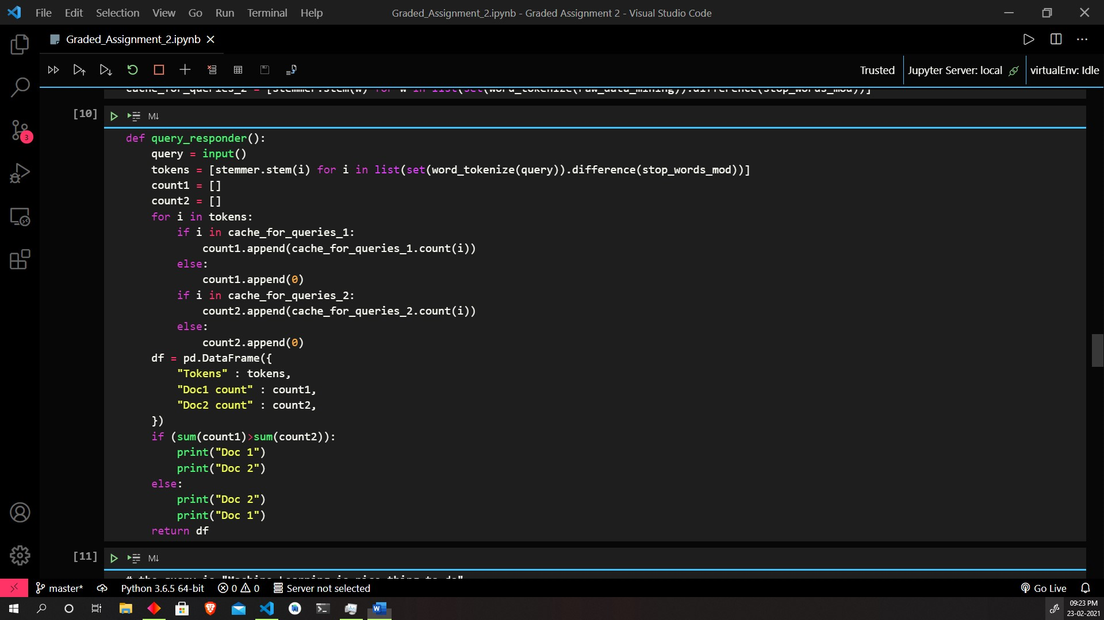

Q2

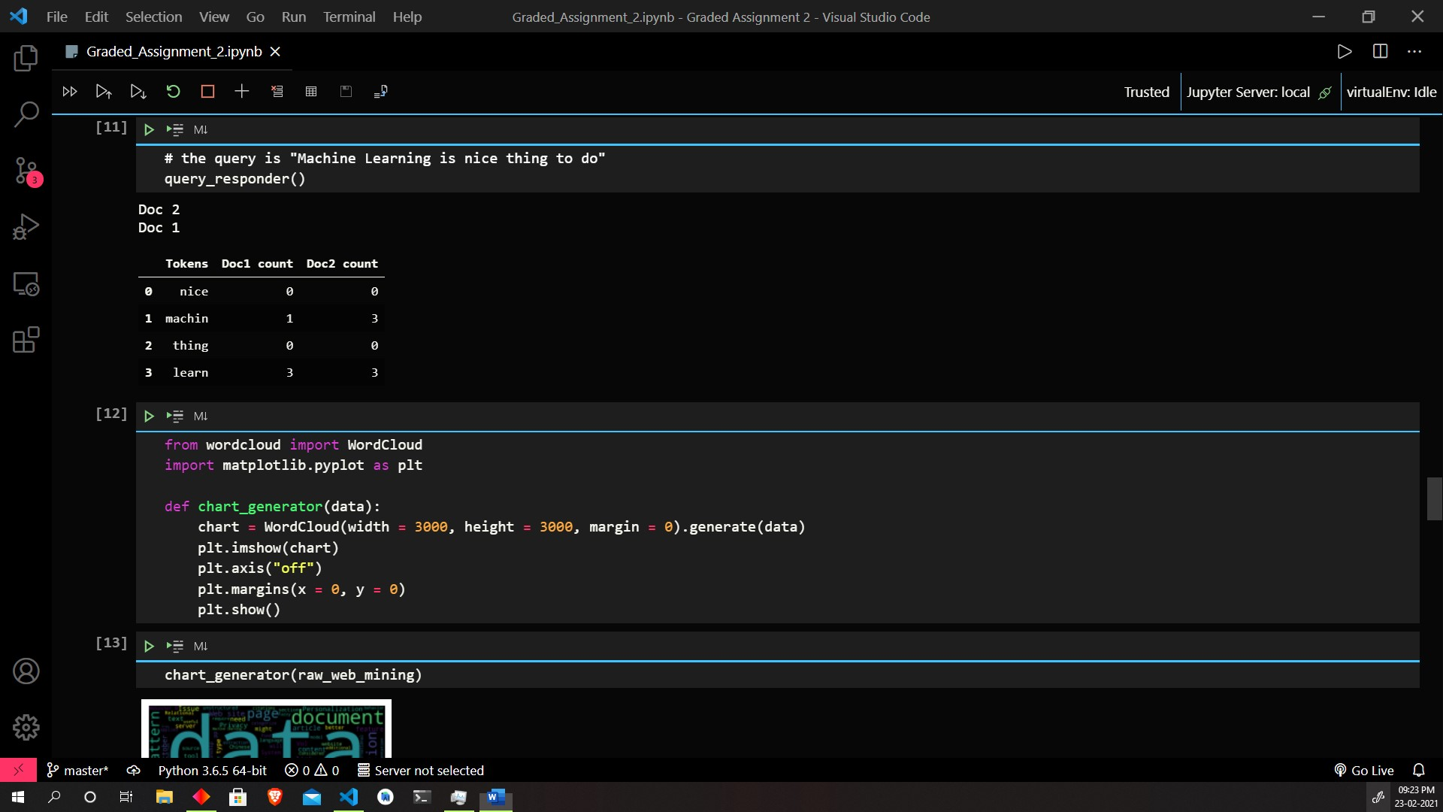

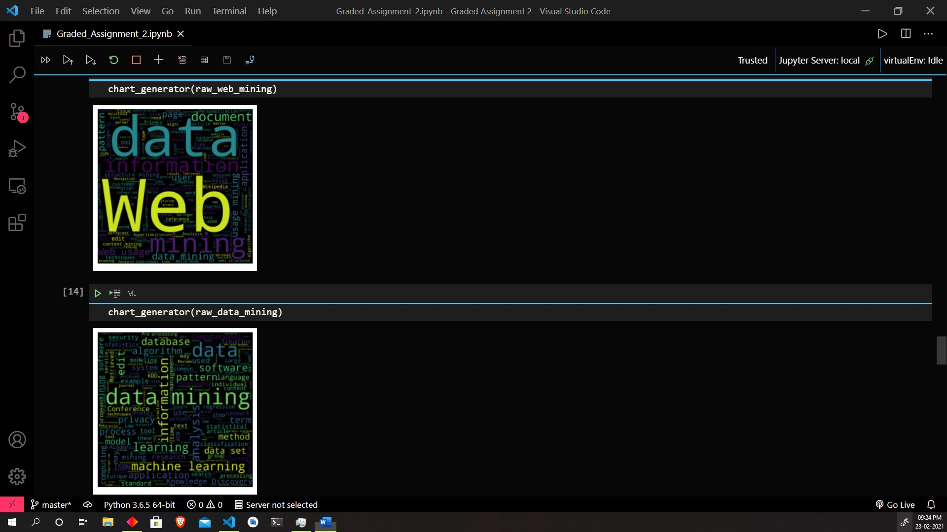

Q3

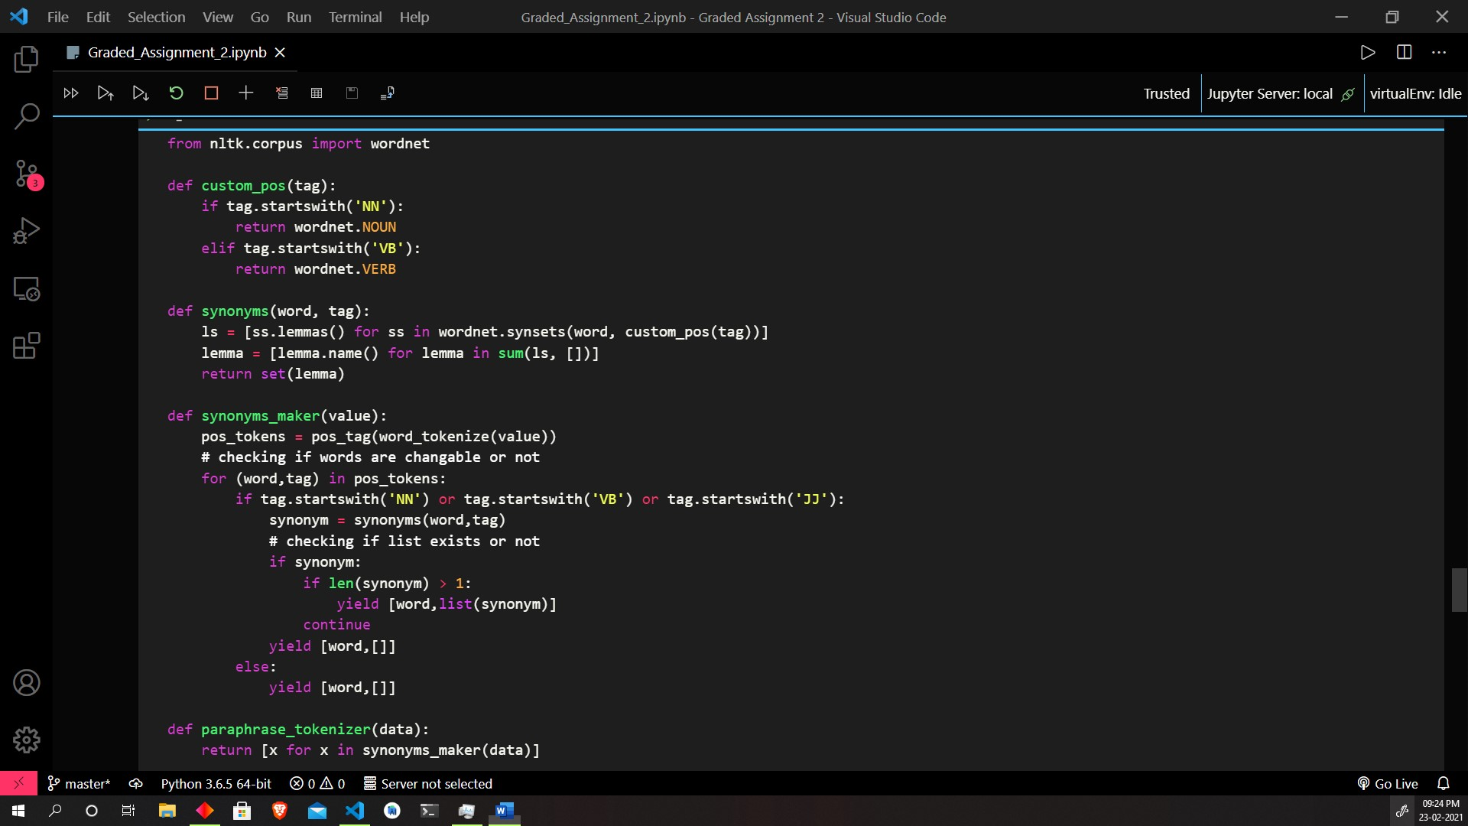

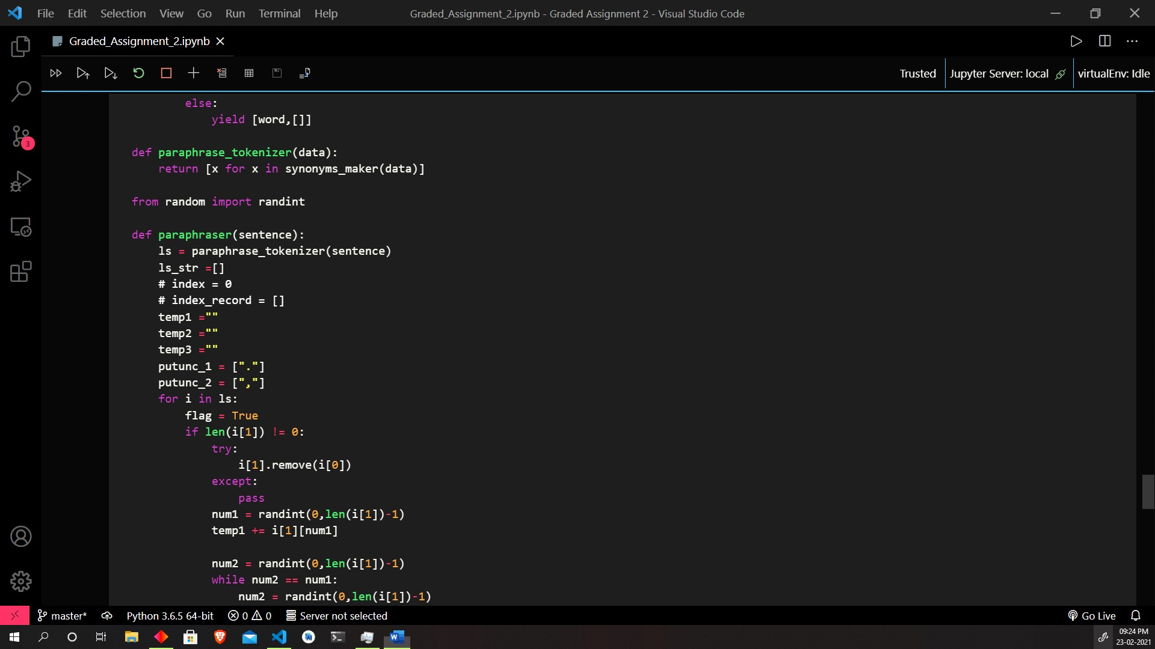

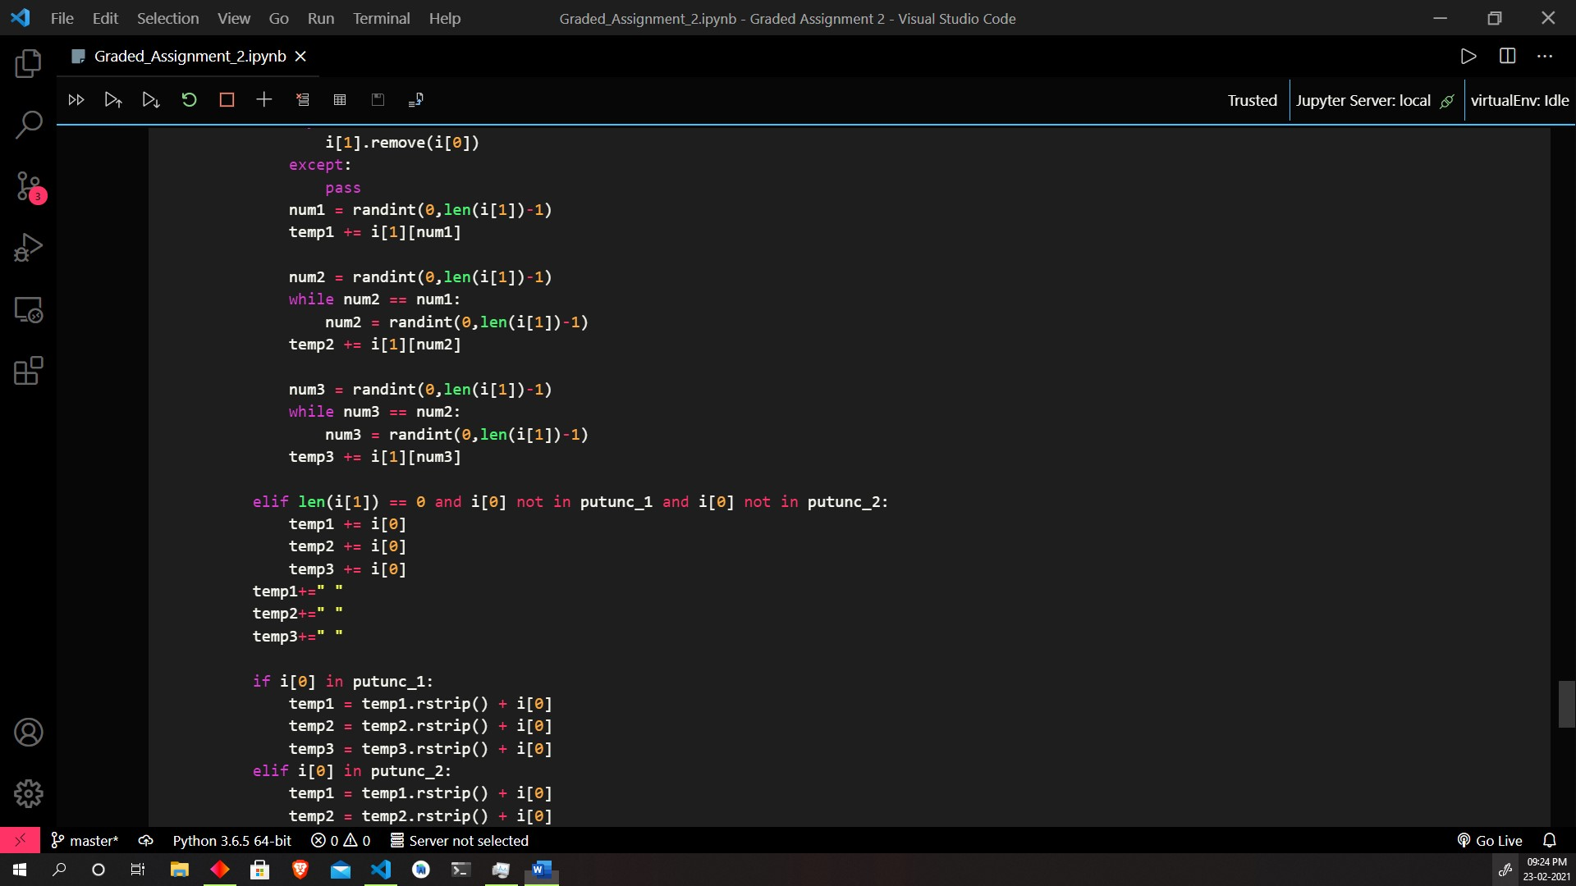

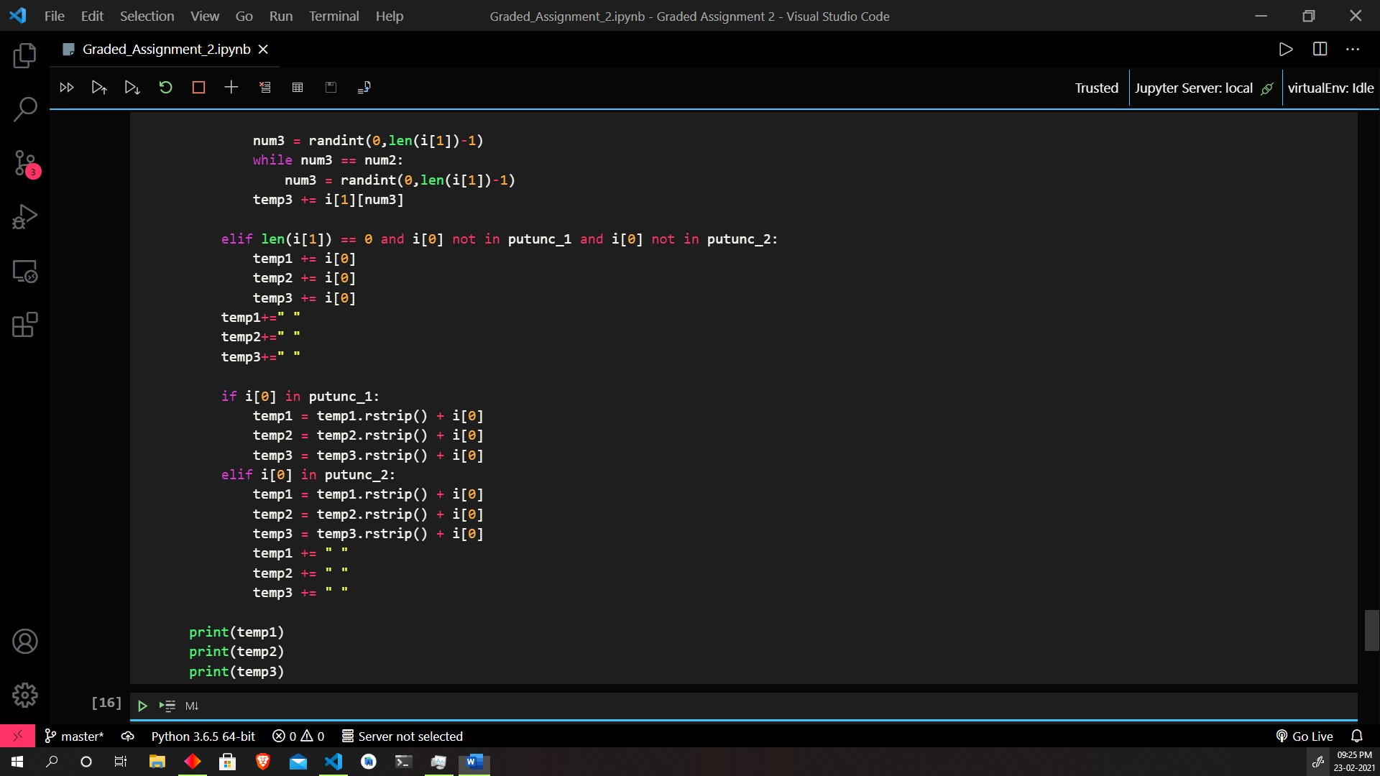

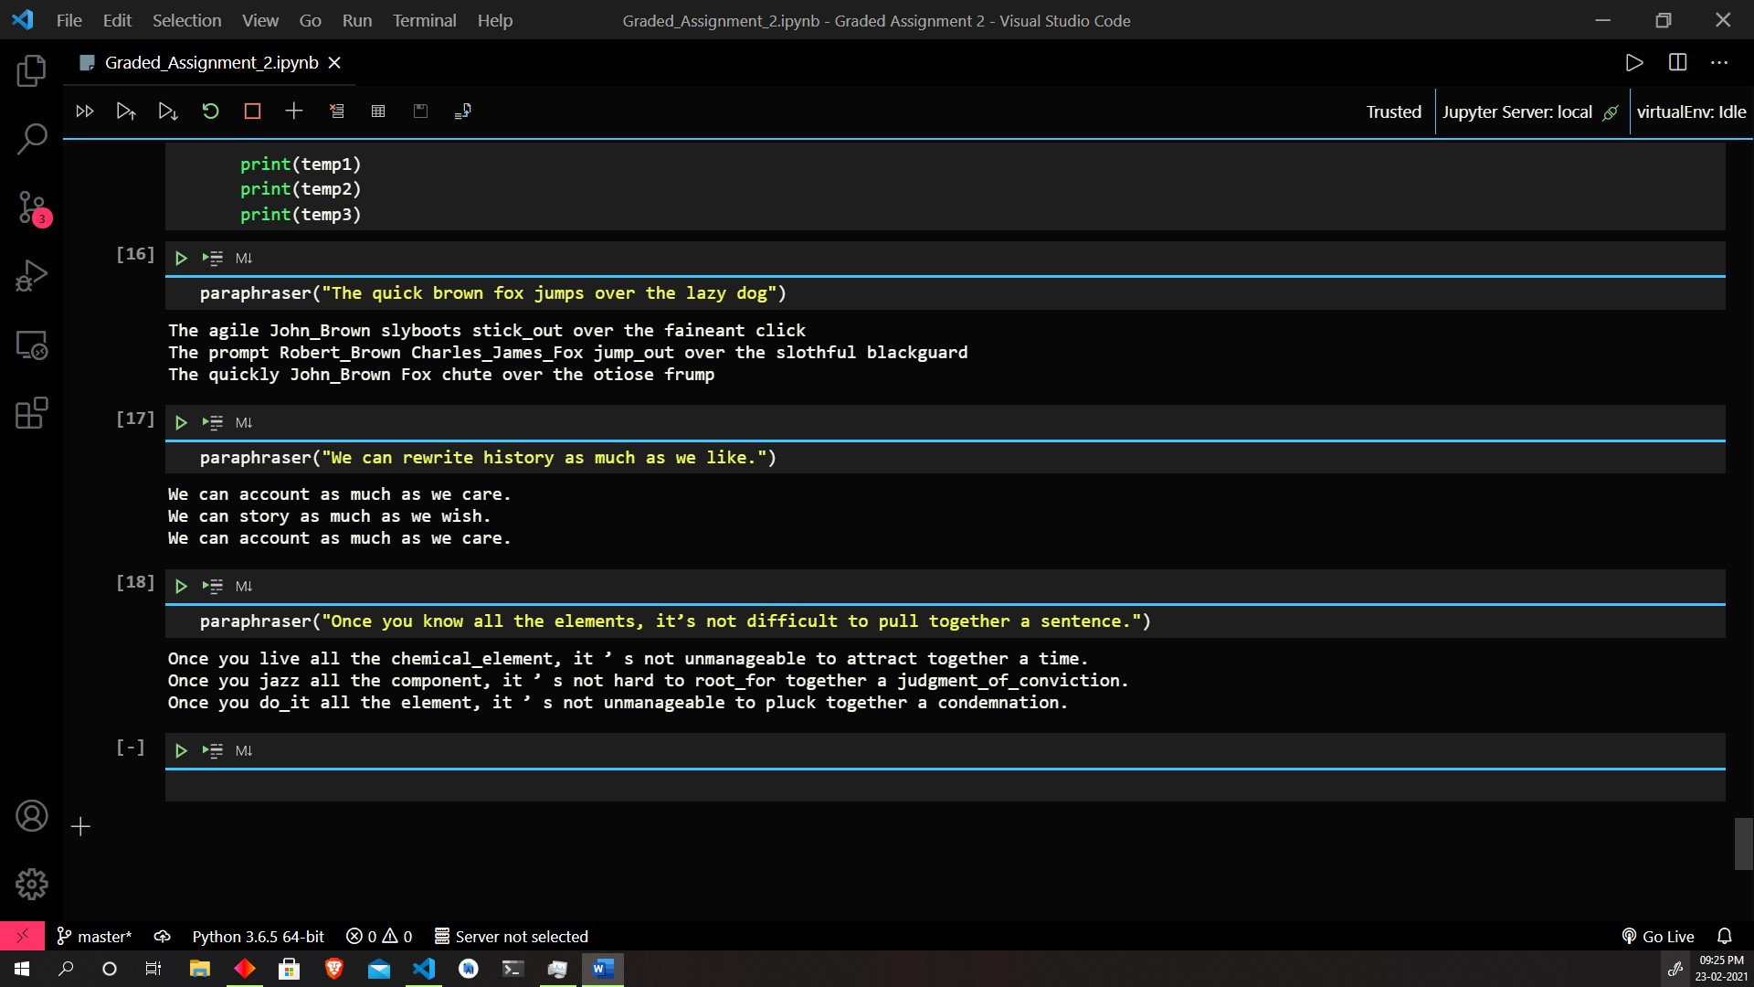

Code:

Q1

import re

from bs4 import BeautifulSoup

from urllib import request

from nltk.tokenize import word_tokenize,sent_tokenize

url1 = "https://en.wikipedia.org/wiki/Web_mining"

html1 = request.urlopen(url1).read().decode('utf8')

raw_web_mining = BeautifulSoup(html1, 'html.parser').get_text()

url2 = "https://en.wikipedia.org/wiki/Data_mining"

html2 = request.urlopen(url2).read().decode('utf8')

raw_data_mining = BeautifulSoup(html2, 'html.parser').get_text()

wb_sentences =  sent_tokenize(raw_web_mining)

data_sentences = sent_tokenize(raw_data_mining)

set_web = set(word_tokenize(raw_web_mining))

set_data = set(word_tokenize(raw_data_mining))

from spacy.lang.en.stop_words import STOP_WORDS

stop_words = set(STOP_WORDS)

stop_words_mod = stop_words.union({'.',',','\'','\"','?','{','}','[',']','<','>','(',')','!'})

stop_web = set_web.difference(stop_words_mod)

stop_data = set_data.difference(stop_words_mod)

def maker(name, ls):

    with open(name,'w') as f:

        for item in list(ls):

            try:

                f.write('%s\n'%item)

            except:

                pass # to remove non-unicode characters

maker('web.txt',stop_web)

maker('data.txt',stop_data)

from nltk import pos_tag

def stopWordMaker(sentences):

    map_final = {}

    collection_stop = []

    collection_pos = []

    for sentence in sentences:

        sentence_ls = sentence.split()

        for word in sentence_ls:

            if word in list(stop_words):

                collection_stop.append(word)

                collection_pos.append(pos_tag([word])[0][1])

        map_final[sentence] = [collection_stop,collection_pos]

        collection_stop = []

        collection_pos = []

    return map_final

map_web = stopWordMaker(wb_sentences)

map_data = stopWordMaker(data_sentences)

import pandas as pd

posTagFrame1 = pd.DataFrame({

    'Original Sentence': [list(i)[0] for i in map_web.items()],

    'List of StopWords' : [list(i)[1][0] for i in map_web.items()],

    'POS-Tag' : [list(i)[1][1] for i in map_web.items()]})

posTagFrame1

posTagFrame2 = pd.DataFrame({

    'Original Sentence': [list(i)[0] for i in map_data.items()],

    'List of StopWords' : [list(i)[1][0] for i in map_data.items()],

    'POS-Tag' : [list(i)[1][1] for i in map_data.items()]})

posTagFrame2

def counter(data):

    ls = []

    for i in terms:

        ls.append(data.count(i))

    return ls

terms = set_data.union(set_web)

Term_Document_BagOfWords = pd.DataFrame({

    "Terms" : list(terms),

    "Doc 1" : counter(list(word_tokenize(raw_web_mining))),

    "Doc 2" : counter(list(word_tokenize(raw_data_mining))),

})

Term_Document_BagOfWords

def boolean(data):

    ls = []

    for i in list(terms):

        if i in data:

            ls.append(1)

        else:

            ls.append(0)

    return ls

data_frame_bool = pd.DataFrame({

    'Terms' : list(terms),

    'Doc 1' : boolean(list(word_tokenize(raw_web_mining))),

    'Doc 2' : boolean(list(word_tokenize(raw_data_mining)))

})

data_frame_bool

def index_finder(data):

    ls = []

    for i in list(terms):

        ls_temp = [index for index, element in enumerate(data) if element == i]

        ls.append(ls_temp)

    return ls

data_frame_complete = pd.DataFrame({

    'Terms' : list(terms),

    'Doc 1' : index_finder(list(word_tokenize(raw_web_mining))),

    'Doc 2' : index_finder(list(word_tokenize(raw_data_mining)))

})

data_frame_complete

from nltk.stem.snowball import SnowballStemmer

stemmer = SnowballStemmer(language='english')

cache_for_queries_1 = [stemmer.stem(w) for w in list(set(word_tokenize(raw_web_mining)).difference(stop_words_mod))]

cache_for_queries_2 = [stemmer.stem(w) for w in list(set(word_tokenize(raw_data_mining)).difference(stop_words_mod))]

def query_responder():

    query = input()

    tokens = [stemmer.stem(i) for i in list(set(word_tokenize(query)).difference(stop_words_mod))]

    count1 = []

    count2 = []

    for i in tokens:

        if i in cache_for_queries_1:

            count1.append(cache_for_queries_1.count(i))

        else:

            count1.append(0)

        if i in cache_for_queries_2:

            count2.append(cache_for_queries_2.count(i))

        else:

            count2.append(0)

    df = pd.DataFrame({

        "Tokens" : tokens,

        "Doc1 count" : count1,

        "Doc2 count" : count2,

    })

    if (sum(count1)>sum(count2)):

        print("Doc 1")

        print("Doc 2")

    else:

        print("Doc 2")

        print("Doc 1")

    return df

# the query is "Machine Learning is nice thing to do"

query_responder()

from wordcloud import WordCloud

import matplotlib.pyplot as plt

def chart_generator(data):

    chart = WordCloud(width = 3000, height = 3000, margin = 0).generate(data)

    plt.imshow(chart)

    plt.axis("off")

    plt.margins(x = 0, y = 0)

    plt.show()

chart_generator(raw_web_mining)

chart_generator(raw_data_mining)

from nltk.corpus import wordnet

def custom_pos(tag):

    if tag.startswith('NN'):

        return wordnet.NOUN

    elif tag.startswith('VB'):

        return wordnet.VERB

def synonyms(word, tag):

    ls = [ss.lemmas() for ss in wordnet.synsets(word, custom_pos(tag))]

    lemma = [lemma.name() for lemma in sum(ls, [])]

    return set(lemma)

def synonyms_maker(value):

    pos_tokens = pos_tag(word_tokenize(value))

    # checking if words are changable or not

    for (word,tag) in pos_tokens:

        if tag.startswith('NN') or tag.startswith('VB') or tag.startswith('JJ'):

            synonym = synonyms(word,tag)

            # checking if list exists or not

            if synonym:

                if len(synonym) > 1:

                    yield [word,list(synonym)]

                continue

            yield [word,[]]

        else:

            yield [word,[]]

def paraphrase_tokenizer(data):

    return [x for x in synonyms_maker(data)]

from random import randint

def paraphraser(sentence):

    ls = paraphrase_tokenizer(sentence)

    ls_str =[]

    # index = 0

    # index_record = []

    temp1 =""

    temp2 =""

    temp3 =""

    putunc_1 = ["."]

    putunc_2 = [","]

    for i in ls:

        flag = True

        if len(i[1]) != 0:

            try:

                i[1].remove(i[0])

            except:

                pass

            num1 = randint(0,len(i[1])-1)

            temp1 += i[1][num1]

            num2 = randint(0,len(i[1])-1)

            while num2 == num1:

                num2 = randint(0,len(i[1])-1)

            temp2 += i[1][num2]

            num3 = randint(0,len(i[1])-1)

            while num3 == num2:

                num3 = randint(0,len(i[1])-1)

            temp3 += i[1][num3]

        elif len(i[1]) == 0 and i[0] not in putunc_1 and i[0] not in putunc_2:

            temp1 += i[0]

            temp2 += i[0]

            temp3 += i[0]

        temp1+=" "

        temp2+=" "

        temp3+=" "

        if i[0] in putunc_1:

            temp1 = temp1.rstrip() + i[0]

            temp2 = temp2.rstrip() + i[0]

            temp3 = temp3.rstrip() + i[0]

        elif i[0] in putunc_2:

            temp1 = temp1.rstrip() + i[0]

            temp2 = temp2.rstrip() + i[0]

            temp3 = temp3.rstrip() + i[0]

            temp1 += " "

            temp2 += " "

            temp3 += " "

    print(temp1)

    print(temp2)

    print(temp3)

paraphraser("The quick brown fox jumps over the lazy dog")

paraphraser("We can rewrite history as much as we like.")

paraphraser("Once you know all the elements, it’s not difficult to pull together a sentence.")